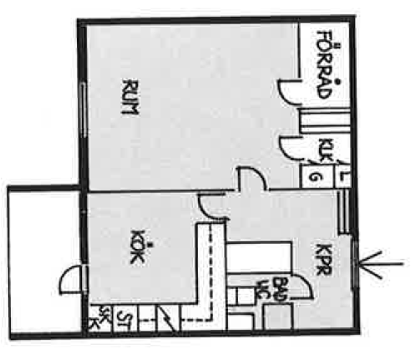

Vita Hasselbacken
1 r.o.k
40 kvm

