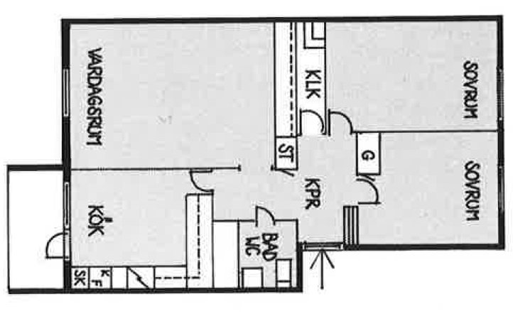

Vita Hasselbacken
3 r.o.k
73 kvm

