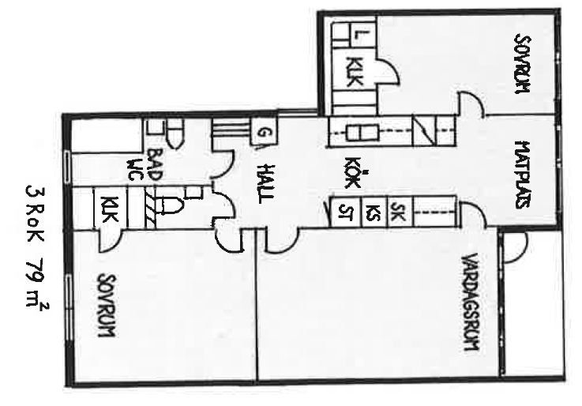

Kristineberg
3 r.o.k
79 kvm

